# *TOP 10 FOOD FOR HELTH*

1. Water

Drink 8 to 12 cups of water daily.

2. Dark Green Vegetables

Eat dark green vegetables at least three to four times a week. Good options include broccoli, peppers, brussel sprouts and leafy greens like kale and spinach.

3. Whole Grains

Eat whole grains sat least two or three times daily. Look for whole wheat flour, rye, oatmeal, barley, amaranth, quinoa or a multigrain. A good source of [fiber](https://www.ucsfhealth.org/education/increasing-fiber-intake) has 3 to 4 grams of fiber per serving. A great source has 5 or more grams of fiber per serving.

4. Beans and Lentils

Try to eat a bean-based meal at least once a week. Try to add legumes, including beans and lentils, to soups, stews, casseroles, salads and dips or eat them plain.

5. Fish

Try to eat two to three serving of fish a week. A serving consists of 3 to 4 ounces of cooked fish. Good choices are salmon, trout, herring, bluefish, sardines and tuna.

6. Berries

Include two to four servings of fruit in your diet each day. Try to eat berries such as raspberries, blueberries, blackberries and strawberries.

7. Winter Squash

Eat butternut and acorn squash as well as other richly pigmented dark orange and green colored vegetables like sweet potato, cantaloupe and mango.

8. Soy

25 grams of [soy protein](https://www.ucsfhealth.org/education/soy-protein-content-of-foods) a day is recommended as part of a low-fat diet to help lower cholesterol levels. Try tofu, soy milk, edamame soybeans, tempeh and texturized vegetable protein (TVP).

9. Flaxseed, Nuts and Seeds

Add 1 to 2 tablespoons of ground flaxseed or other seeds to food each day or include a moderate amount of nuts – 1/4 cup – in your daily diet.

10. Organic Yogurt

Men and women between 19 and 50 years of age need 1000 milligrams of [calcium](https://www.ucsfhealth.org/education/getting-enough-calcium) a day and 1200 milligrams if 50 or older. Eat calcium-rich foods such as nonfat or low-fat dairy products three to four times a day. Include organic choice.

# *HELTH DRINKS*



# Best Choice: Water

## Water is essential for your body. It prevents dehydration, constipation, and kidney stones. Plus, with no calories, it’s the best beverage for your waistline. If you add 1 to 3 cups of water a day to your diet, you could end up taking in less fat, salt, sugar, and up to 200 fewer calories per day. Too plain? Calorie-free flavor drops sweeten, but may have artificial flavors, colors, or preservatives. Try a squeeze of citrus instead.

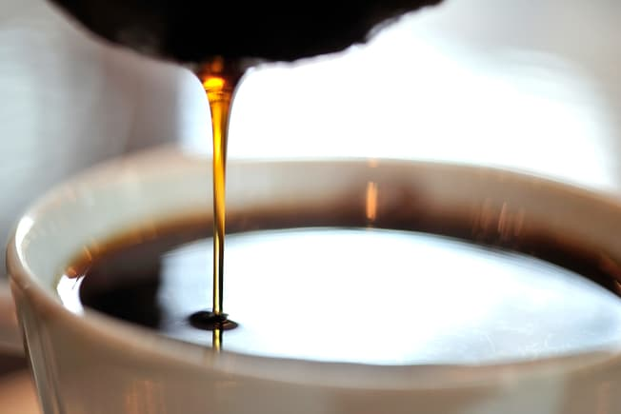

**Best Choice: Filtered Coffee**

Coffee has gotten a bad rap before, but studies show it may protect against type 2 diabetes, liver disease, and lower your odds of heart disease. Three to five cups a day seems to be healthy, as long as you go easy on the cream and sugar. But if you’re pregnant or breastfeeding, ask your doctor how much to sip. If you have high cholesterol, brew yours with a paper filter. It gets rid of a substance called cafestol that can raise LDL cholesterol.



**Best Choice: Tea**

Green, black, and other kinds are full of antioxidants, which may protect you against some types of cancer, stroke, heart disease, and high blood pressure. Plus, unsweetened brews are low in calories. Whether you like it hot or iced, the healthiest kinds are the ones you brew at home -- without the added sugars that bottled tea can have.

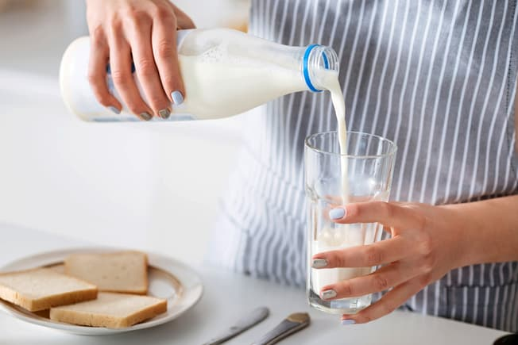

**Good Choice: Milk**

It’s a powerhouse of nutrients like calcium, vitamin D, and potassium, which keep your muscles, teeth, and bones healthy. And a cup of it has more protein than a large egg. To get more nutrition from fewer calories, look for low-fat and skim options. Some nondairy milks -- soy, oat, almond, and others -- have some of the same nutrients as cow’s milk, but the concentration of these is low per serving.